1. Write a query in SQL to find the name and year of the movies.

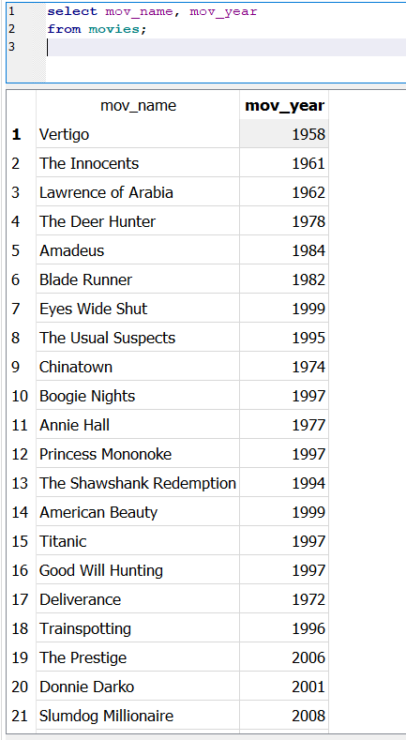

1. Write a query in SQL to find the year when the movie American Beauty released.

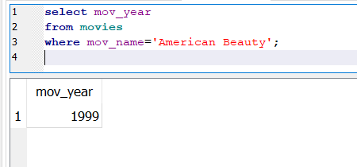

1. Write a query in SQL to find the movie which was released in the year 1999.

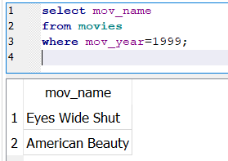

1. Write a query in SQL to find the movies which was released before 1998.

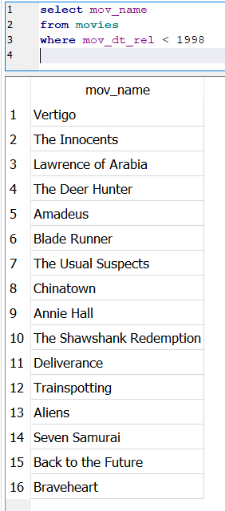

1. Write a query in SQL to return the name of all reviewers and name of movies together in a single list.

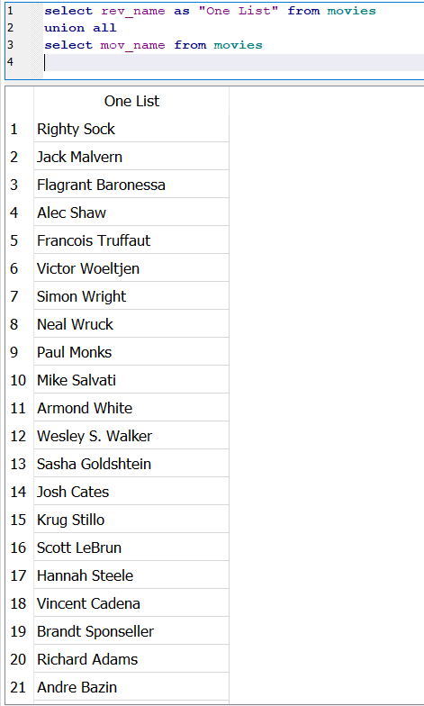

1. Write a query in SQL to find the name of all reviewers who have rated 7 or more stars to their rating.

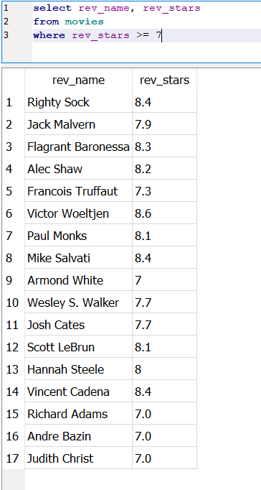

1. Write a query in SQL to find the titles of all movies that have no ratings.

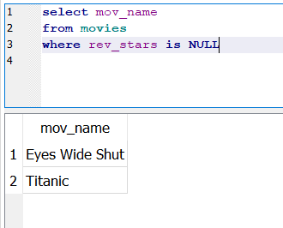

1. Write a query in SQL to find the titles of the movies with ID 905, 907, 917.

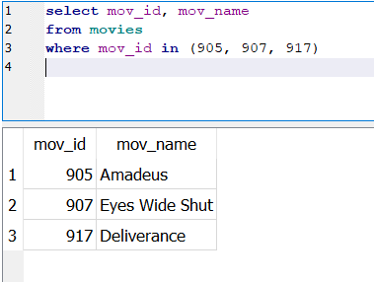

1. Write a query in SQL to find the list of all those movies with year which include the words Boogie Nights.

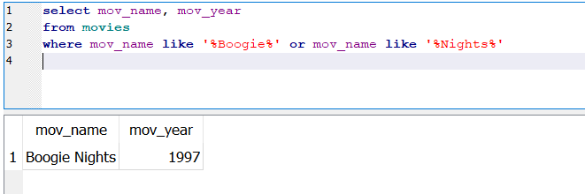

1. Write a query in SQL to find the ID number for the actor whose first name is 'Woody' and the last name is 'Allen'.

